Vernacular Names: Chinese Lantern Tree | Scientific Name: Hernandia Sonora L.
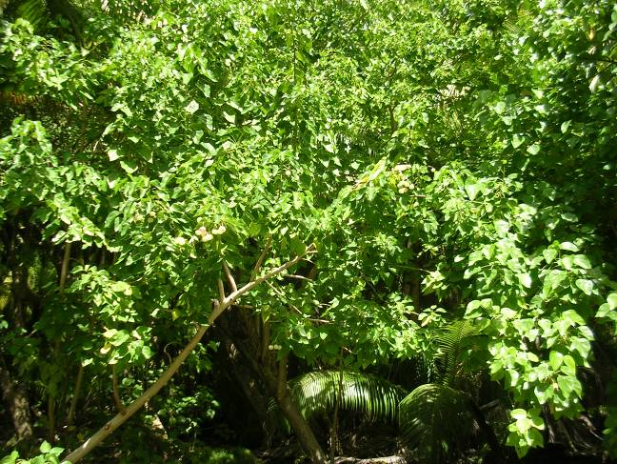 | 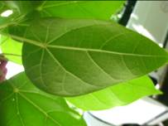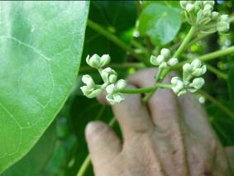  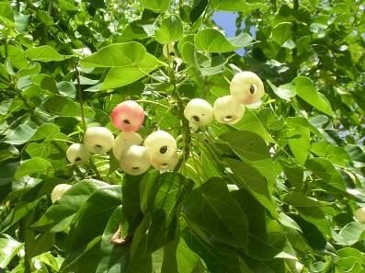
Full tree form | Details of leaf, flower, fruit
Native or Introduced: Native

Description: Large to very large tree, silver-grey bark, with a rough, warty appearance. Leaves distinctive because petiole (leafstalk) does not adjoin the leaf edge, but some centimetres inside the leaf lamina (see arrow on photo above). Cluster of small white flowers, each with long corolla tube. Fruit a small, globose, hollow papery sphere with a hole at the base, coloured green and often rosy, giving it the name Chinese Lantern Tree. The rough silvery bark, leaf petiole attachment, and fruit make this tree very distinctive.

Habitat: Particularly common on coral rubble surfaces with almost no soil, throughout Chagos, but grows in deeper soil areas as well. Rarely close to the shoreline. Forms beautiful dense woodlands under which almost nothing else grows, except for the Bird’s Nest Fern - Asplenium nidus – that grows as large tussocks beneath the trees and as an epiphyte on the tree’s bark. Other areas comprising larger trees as true forest, for example on the southern end of Eagle Island.

Human uses: None noted. Possible medicinal applications.

Significance: Excellent woodland tree in rubble areas where few other trees apart from coconuts can grow. Also seems to be able to hold its own against coconut or Scaevola invasion. It is a good fast-growing nursery species.

Propagation: Seed, saplings common beneath canopy. Might grow from cuttings?

